**Title: Recipe Book Database Management**

*Project Synopsis Submitted*

*to*

**MANIPAL ACADEMY OF HIGHER EDUCATION**

*For Partial Fulfillment of the Requirement for the*

*Award of the Degree*

*Of*

**Bachelor of Technology**

*in*

**INFORMATION TECHNOLOGY**

*by*

**ANUSHA V (Reg. No. 220911013)**

**SAHITYA K (Reg. No. 220911051)**

**SAYALI SACHIN CHORGE (Reg. No. 220911266)**

*Under the guidance of*

Dr. AKSHAY K C Dr. RAGHAVENDRA S

Assistant Professor - Senior Scale Assistant Professor

Department of I&CT Department of I&CT

Manipal Institute of Technology Manipal Institute of Technology

Manipal, Karnataka, India Manipal, Karnataka, India



**FEBRUARY 2023**

**Objective:**

The objective of the **“Recipe Book Database Management System”** is to enhance the culinary experience by offering a personalized recipe collection. The software allows users to browse desired recipes along with the nutritional information to make informed choices, and nearby restaurants to order the same.

Users start with a login page, where they select their food preferences. The platform provides a dynamic home page displaying a curated list of recipes. On hover, users can view nutritional information, including calorie statistics, to make informed choices.

**Scope:**

This project is helpful to browse curated recipes accompanied by nutritional values. The recipe detail pages offer a comprehensive view of the dish, empowering users to not only follow the recipe but also order it from nearby restaurants. This integration of virtual recipe exploration with practical dining options bridges the gap between culinary inspiration and real-world enjoyment. The software will be able to handle all the necessary information.

**Project Description:**

The software to be produced is on the Recipe Book Database Management System.

The project encompasses user authentication, profile creation, and the ability to customize food preferences. The home page features a diverse collection of recipes, offering engaging on-hover interactions featuring nutritional insights. Users can actively engage with recipes by liking them, leaving comments, and even editing or deleting their comments. The platform highlights user activity with sections displaying   
Last Viewed Recipe, Most Liked Recipe, and Top Reviewed recipes.

Upon clicking a specific dish, users access a detailed recipe page, which not only includes the step-by-step preparation instructions but also provides options to order the dish from nearby restaurants. The ordering functionality integrates with restaurants that offer the selected recipe, creating a seamless connection between recipe exploration and real-world dining experiences.

This integration of virtual recipe exploration with practical dining options bridges the gap between culinary inspiration and real-world enjoyment. With a focus on user-friendly design and robust functionality, the project promises to elevate the joy of cooking and dining for its users.

**Hardware Requirements:**

**Processor:**  Intel dual core or above

**Processor Speed:** 1.0GHZ or above

**RAM:**  1 GB RAM or above

**Hard Disk:**  20 GB hard disk or above

**Software Requirements:**

**Language:**  HTML, CSS, JS

**UI/UX Framework:** Figma, Canva

**API’s:** Google Maps API

**Database:**  SQL PLUS

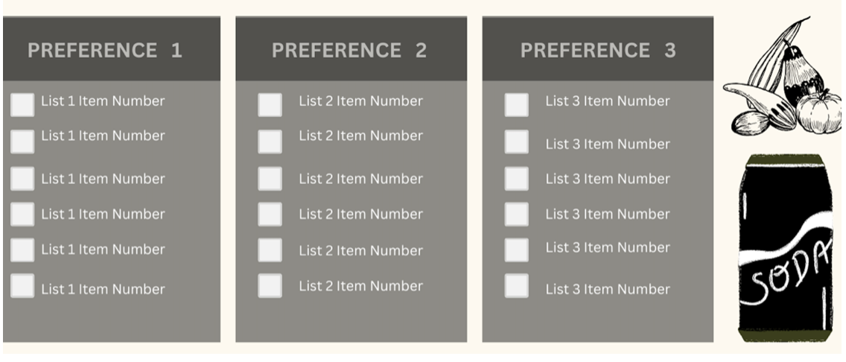

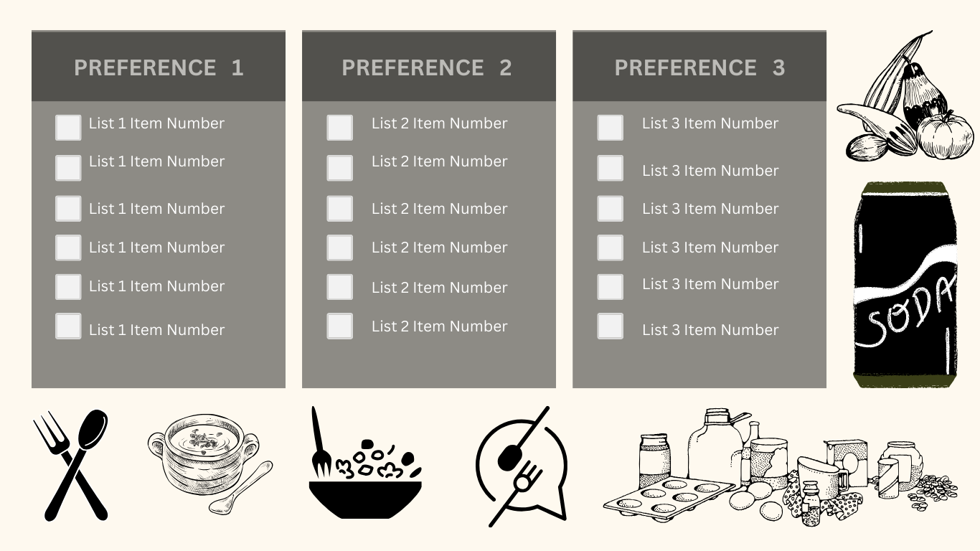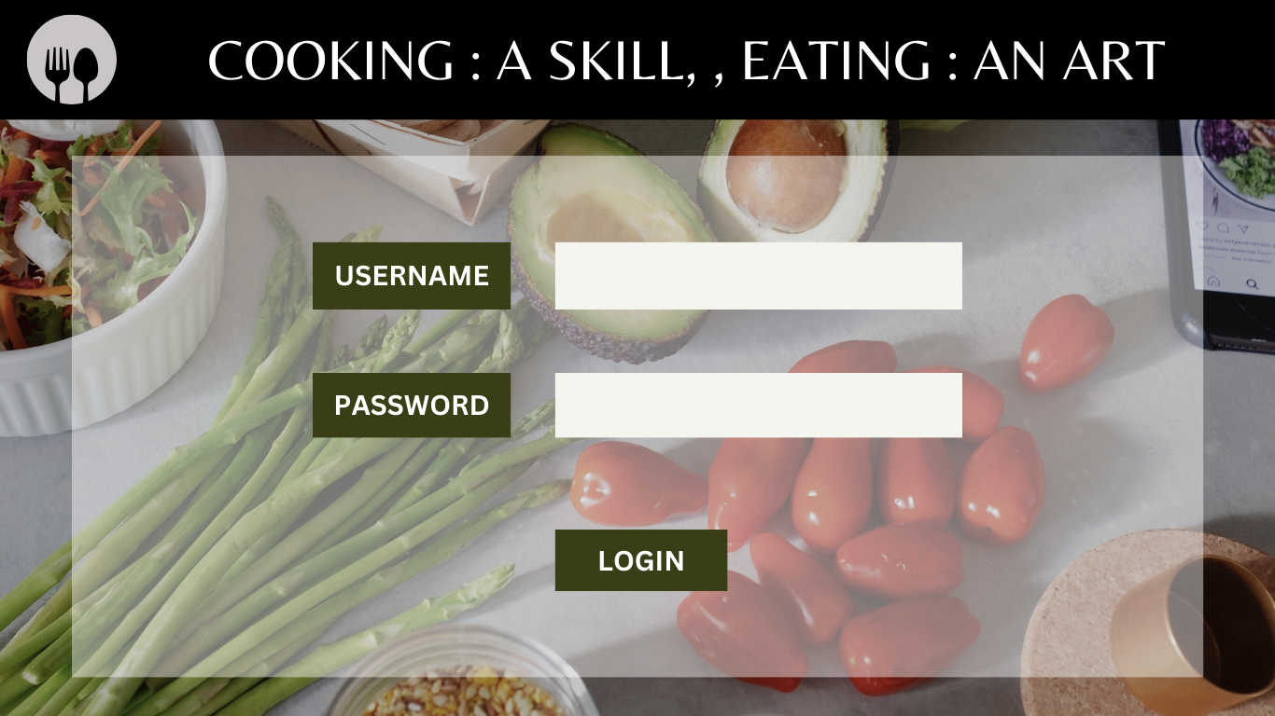**UI/UX Prototype:**

**FEBRUARY 2023**

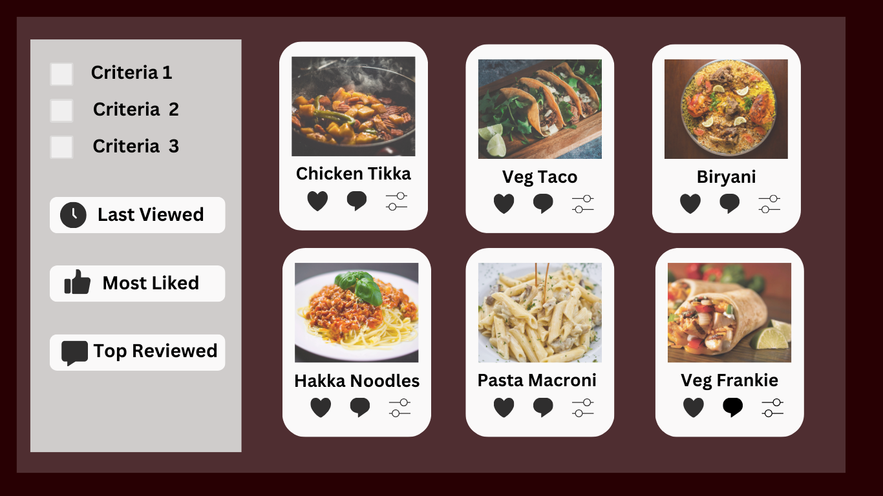

**FEBRUARY 2023**

**Submitted By:**

|  |  |  |  |  |
| --- | --- | --- | --- | --- |
| **Name** | **Registration number** | **Roll Number** | **Semester & Branch** | **Section** |
| Anusha V | 220911013 | 3 | IV (IT) | B |
| Sahitya K | 220911051 | 12 | IV (IT) | B |
| Sayali Sachin Chorge | 220911266 | 18 | IV (IT) | B |

***This Marks The End Of Synopsis***